

DEPARTMENT OF COMPUTER SCIENCE & ENGINEERING ACADEMIC YEAR 2024-2025

EVEN SEMESTER



**CS23432 SOFTWARE ENGINEERING LAB LAB MANUAL**

**SECOND YEAR FOURTH SEMESTER 2024-2025**

**EVEN SEMESTER**

|  |  |
| --- | --- |
| **Ex No** | **List of Experiments** |
| 1 | Study of Azure DevOps |
| 2 | DesigningProject using AGILE-SCRUM Methodology. |
| 3 | Agile Planning |
| 4 | User stories – Creation |
| 5 | Architecture Diagram Using AZURE |
| 6 | Designing Usecse and Class Diagram |
| 7 | Designing Interaction Diagrams |
| 8 | Design Interface |
| 9 | Implementation–DesignaWebPagebasedonScrum Methodology |
| 10 | TestingusingAzure. |
| 11 | Deployment |

|  |  |
| --- | --- |
| **Requirements** | |
| Hardware | Intel i3, CPU @ 1.20GHz 1.19 GHz, 4 GB RAM,  32 Bit Operating System |
| Software | StarUML , Azure |

# LAB PLAN

**CS19442-SOFTWAREENGINEERINGLAB**

|  |  |  |  |  |
| --- | --- | --- | --- | --- |
| **Ex No** | **Date** | **Topic** | **Page No** | **Sign** |
| 1 |  | Study of Azure DevOps |  |  |
| 2 |  | Writing Problem Statement |  |  |
| 3 |  | Designing Project using AGILE-SCRUM Methodology by using Azure. |  |  |
| 4 |  | Agile Planning |  |  |
| 5 |  | User stories – Creation |  |  |
| 6 |  | Architecture Diagram Using AZURE |  |  |
| 7 |  | Designing Use case Diagram using StarUML |  |  |
| 8 |  | Designing Activity Diagrams using StarUML |  |  |
| 9 |  | Designing Sequence Diagrams using StarUML |  |  |
| 10 |  | Design Class Diagram |  |  |
| 10 |  | Design User Interface |  |  |
| 11 |  | Implementation–Design a Web Page based on Scrum Methodology |  |  |
| 12 |  | Testing |  |  |
| 13 |  | Deployment |  |  |

**Course Outcomes (COs)**

**Course Name : Software Engineering CourseCode:CS23432**

|  |  |
| --- | --- |
| **CO 1** | Understand the software development process models. |
| **CO 2** | Determine the requirements to develop software |
| **CO 3** | Apply modeling and modeling languages to design software products |
| **CO 4** | Apply various testing techniques and to build a robust software products |
| **CO 5** | Manage Software Projects and to understand advanced engineering concepts |

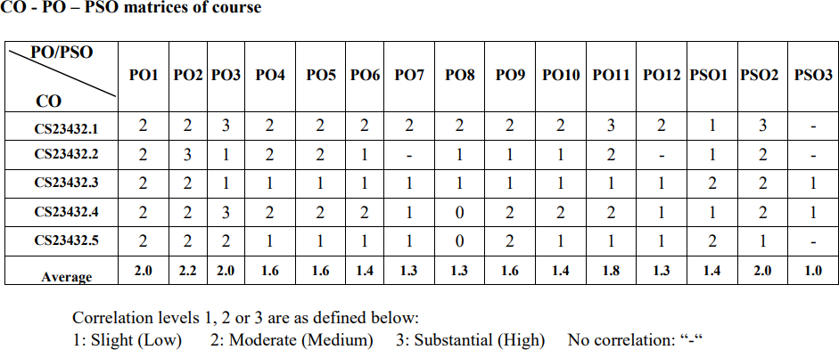

**EX NO: 1**

**Study of Azure DevOps**

**AIM:**

To study how to create an agile project in Azure DevOps environment.

**STUDY:**

Azure DevOps is a cloud-based platform by Microsoft that provides tools for DevOps practices, including CI/CD pipelines, version control ,agile planning, testing ,and monitoring.It supports teams in automating software development and deployment.

1. Understanding Azure DevOps

Azure DevOps consists of five key services:

Azure Repos(Version Control)

Supports Git repositories and Team Foundation Version Control(TFVC). Provides features like branching, pull requests, and code reviews.

Azure Pipelines (CI/CD)

Automates build, test, and deployment processes.

Supports multi-plat form builds (Windows,Linux, macOS).

Works with Docker ,Kubernetes ,Terraform ,and cloud providers(Azure,AWS, GCP).

Azure Boards (Agile Project Management)

Manages work using Kanban boards, Scrum boards ,and dashboards . Tracks user stories, tasks, bugs, sprints, and releases.

Azure Test Plans(Testing)

Provides manual, exploratory, and automated testing. Supports test case management and tracking.

Azure Artifacts (Package Management)

Stores and manages NuGet ,npm ,Maven ,and Pythonpackages. Enables versioning and secure access to dependencies.

## Getting Started with Azure DevOps

Step1:Create an Azure DevOps Account Visit Azure DevOps.

Sign in with a Microsoft Account. Create an Organization and a Project.

Step 2: Set Up a Repository (Azure Repos) Navigate to Repos.

Choose Gitor TFVC for version control. Clone the repository and push your code.

Step 3: Configure a CI/CD Pipeline (Azure Pipelines) Go to Pipelines→NewPipeline.

Select a source code repository (Azure Repos, GitHub, etc.).

Define the pipeline using YAML or the Classic Editor. Run the pipeline to build and deploy the application.

Step4 : Manage Work with Azure Boards Navigate to Boards.

Create work items, user stories, and tasks. Organize sprints and track progress.

Step5:Implement Testing (Azure Test Plans) Go to Test Plans.

Create and run test cases

View test results and track bugs.

## Result:

The study was successfully completed.

**EX NO: 2**

# PROBLEM STATEMENT

**AIM:**

To prepare PROBLEM STATEMENT for your given project.

## Problem Statement:

**Smart Property Listing, Search & Review Platform**

In the real estate market, buyers and sellers often struggle with finding reliable listings and verifying the authenticity of dealers. This project aims to build a smart property listing and search platform where users can post properties for sale with key details like price, location, and contact information. Buyers can filter listings based on criteria such as BHK, area, amenities, and locality. A review system enables users to share their post-transaction experiences, building trust and helping others make informed decisions. Verified builders can log in to post new residential and commercial projects to attract potential buyers.

## Result:

The problem statement was written successfully.

# EX NO: 3

**Aim**:

To prepare an Agile Plan.

# THEORY

# AGILE PLANNING

Agile planning is a part of the Agile methodology, which is a project management style with an incremental, iterative approach. Instead of using an in-depth plan from the start of the project—which is typically product-related—Agile leaves room for requirement changes throughout and relies on constant feedback from end users.

With Agile planning, a project is broken down into smaller, more manageable tasks with the ultimate goal of having a defined image of a project’s vision. Agile planning involves looking at different aspects of a project’s tasks and how they’ll be achieved , for example:

* Road maps to guide a product’s released schedule
  + Sprints to work on one specific group of tasks at a time
  + A feedback plan to allow teams to stay flexible and easily adapt to change

User stories, or the tasks in a project, capture user requirements from the end user’s perspective Essentially, with Agile planning, a team would decide on a set of userstories to action at any given time, using them as a guide to implement new features or functionalities in a tool. Looking at tasks as userstories is a helpful way to imagine how a customer may use a feature and help steams prioritize work and focus on delivering value first.

* + Steps in Agile planning process
    1. Define vision
    2. Set clear expectations on goals
    3. Define and break down the product roadmap
    4. Create tasks based on user stories
    5. Populate product backlog
    6. Plan iterations and estimate effort
    7. Conduct daily stand-ups
    8. Monitor and adapt

Result:

Thus the Agile plan was completed successfully.

# EX NO: 4

## Aim:

# CREATE USER STORIES

To create User Stories

# THEORY

A user story is an informal, general explanation of a software feature written from the perspective of the end user. Its purpose is to articulate how a software feature will provide value to the customer.

User story template

## "Asa[role], I [wantto], [so that]."

**Procedure:**

1. Open your web browser and go to the Azure website: [*https://azure.microsoft.com/en-in*](https://azure.microsoft.com/en-in). Sign in using your Microsoft account credentials. If you don't have an account, you'll need to create one.
2. If you don’t have a Microsoft account, you can sign up for

[*https://signup.live.com/?lic=1*](https://signup.live.com/?lic=1)

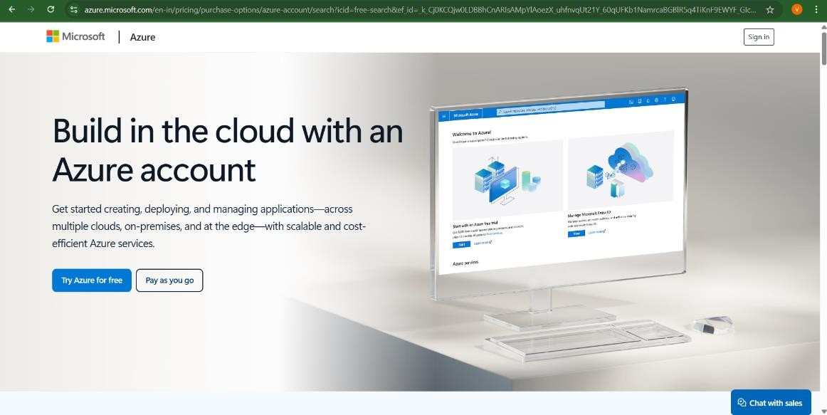

1. Azure home page

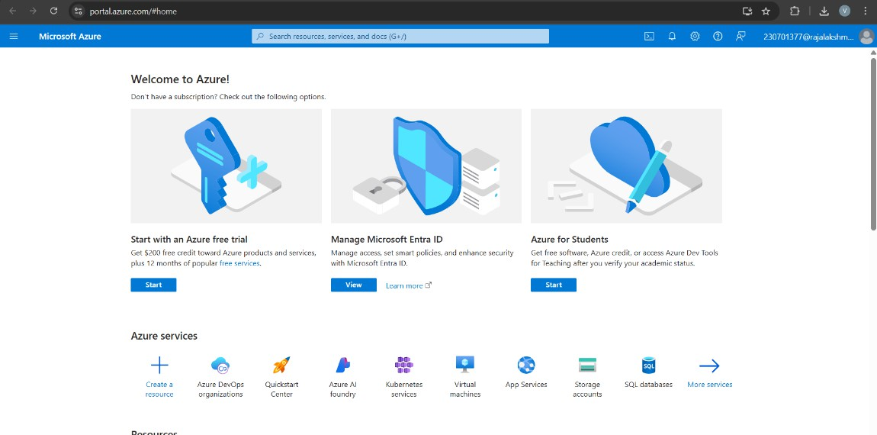

1. Open DevOps environment in the Azure platform by typing Azure DevOps Organizations in the search bar.

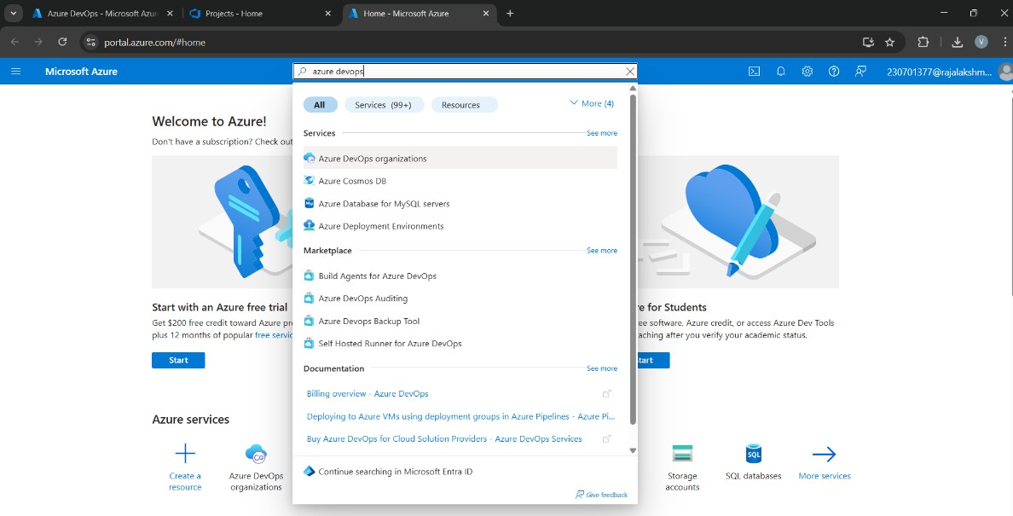

1. Click on the MyAzure DevOps Organization link and create an organization and you should be taken to the Azure DevOps Organization Home page.

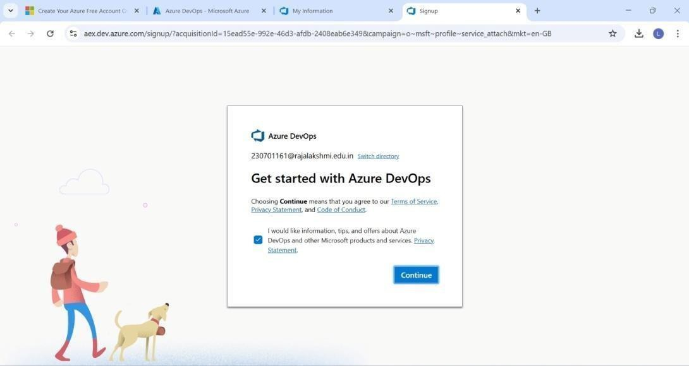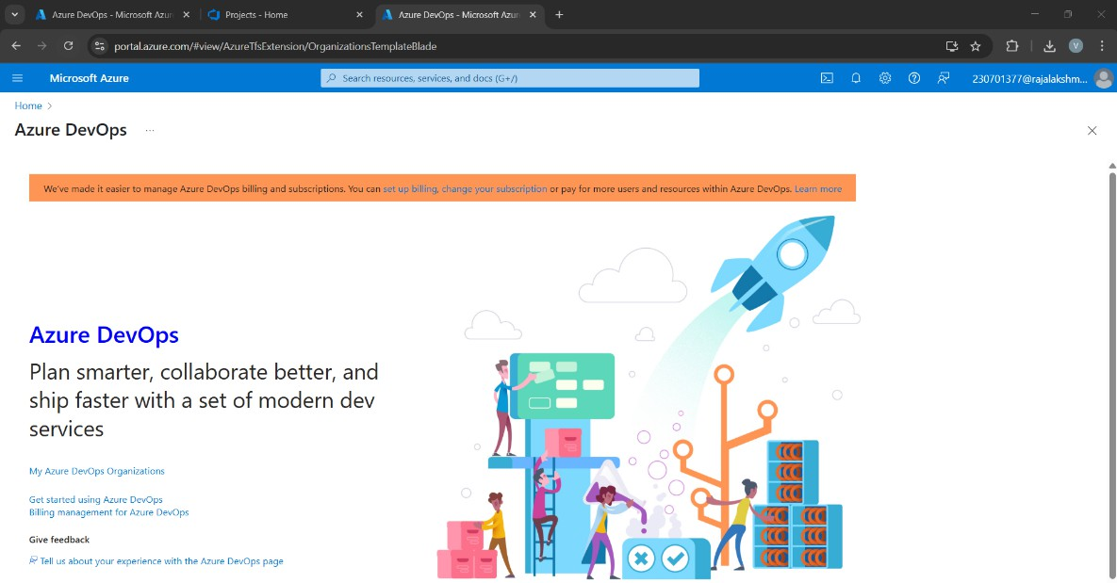

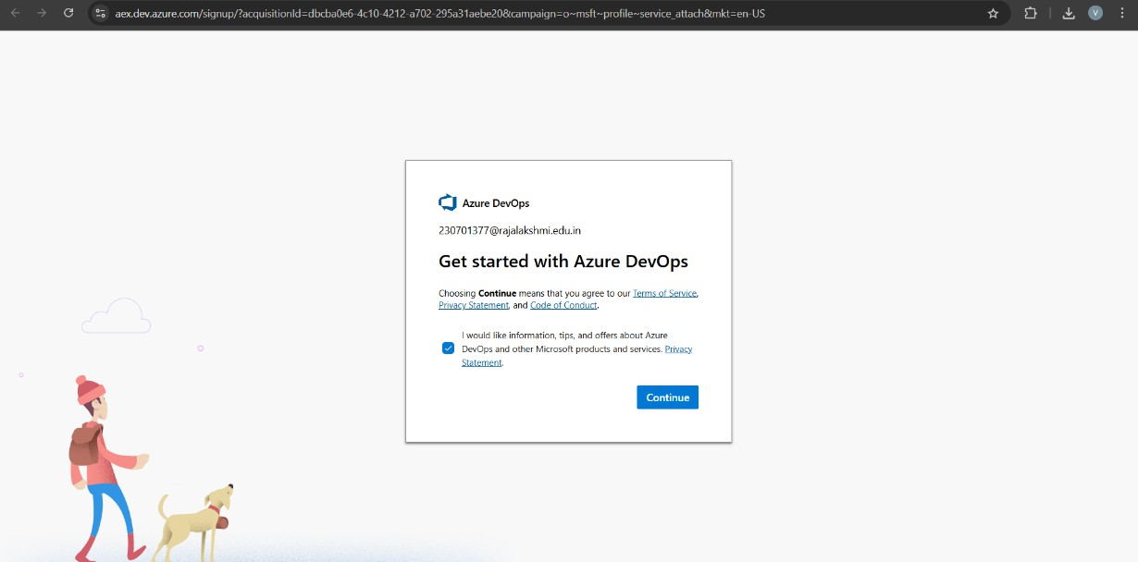

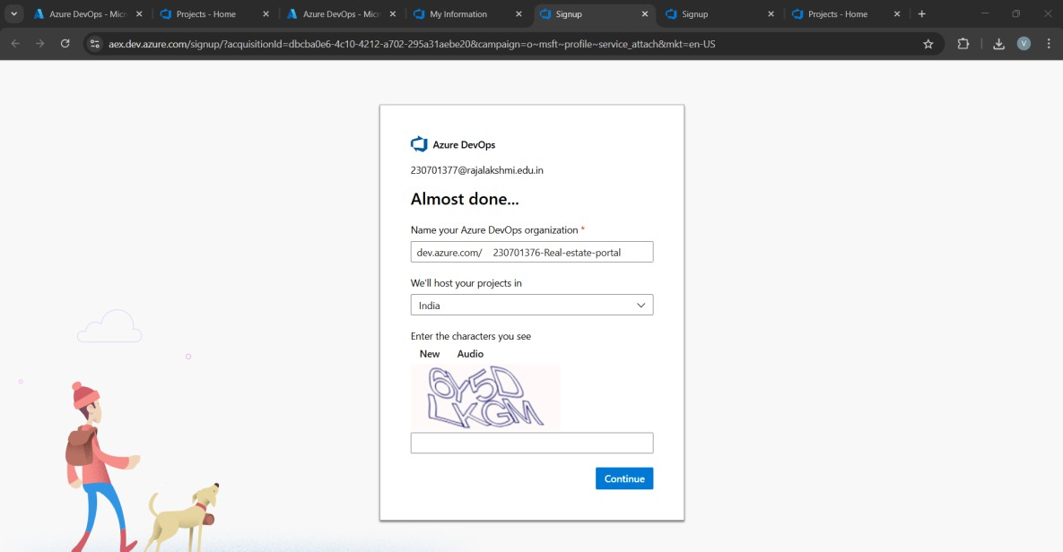

1. Create the First Project in Your Organization

After the organization is setup,you’ll need to create your first **project**.This is where you'll begin to manage code, pipelines, work items, and more.

* 1. On the organization’s **Homepage**, click on the **New Project** button.
  2. Enter the project name, description, and visibility options:
     + **Name**: Choose a name for the project(e.g.,LMS).
     + **Description**: Optionally,add a description to provide more context about the project.
     + **Visibility**: Choose whether you want the project to be **Private**

(accessible only to those invited) or **Public**(accessible to anyone).

* 1. Once you’ve filled out the details, click **Create** to setup your first project.

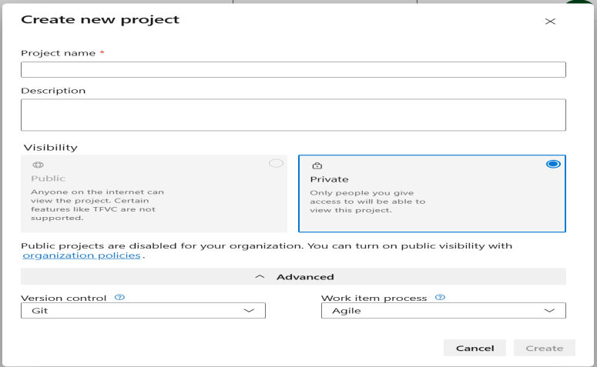

1. Once logged in, ensure you are in the correct organization. If you're part of multiple organizations, you can switch between them from the top left corner (next to your user profile).Click on the Organization name ,and you should be taken to the Azure DevOps Organization Home page.

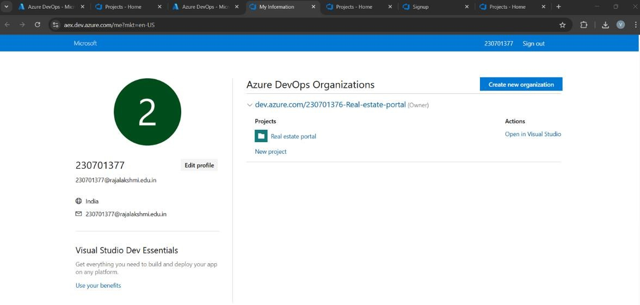

1. Project Dashboard

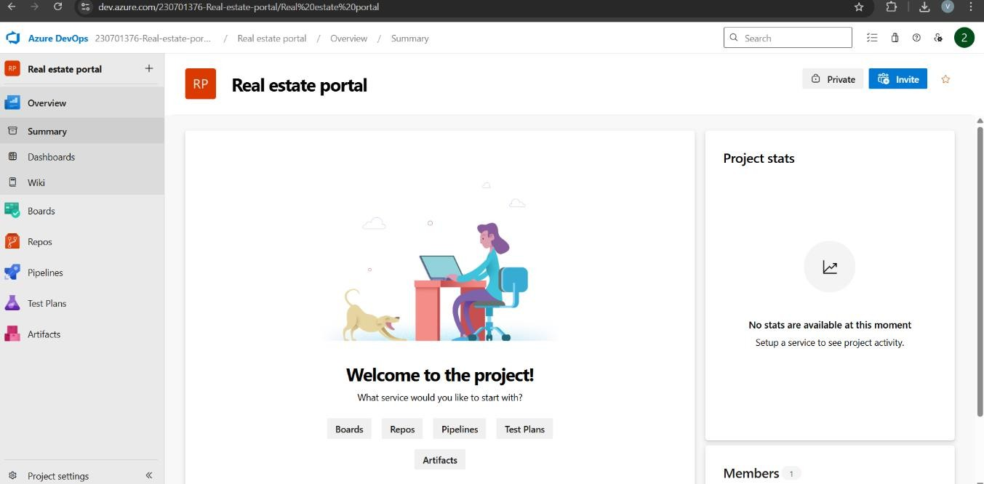

1. Project dashboard
2. To manage user stories
   1. From the **left-hand navigation menu**, click on **Boards** .This will take you to the main **Boards** page, where you can manage work items, backlogs, and sprints.
   2. On the **work items** page, you'll see the option to **Add a work item** at the top. Alternatively, you can find a **+** button or **Add New Work Item** depending on the view you're in. From the **Add a work item** dropdown, select **User Story**. This will open a form to enter details for the new User Story.

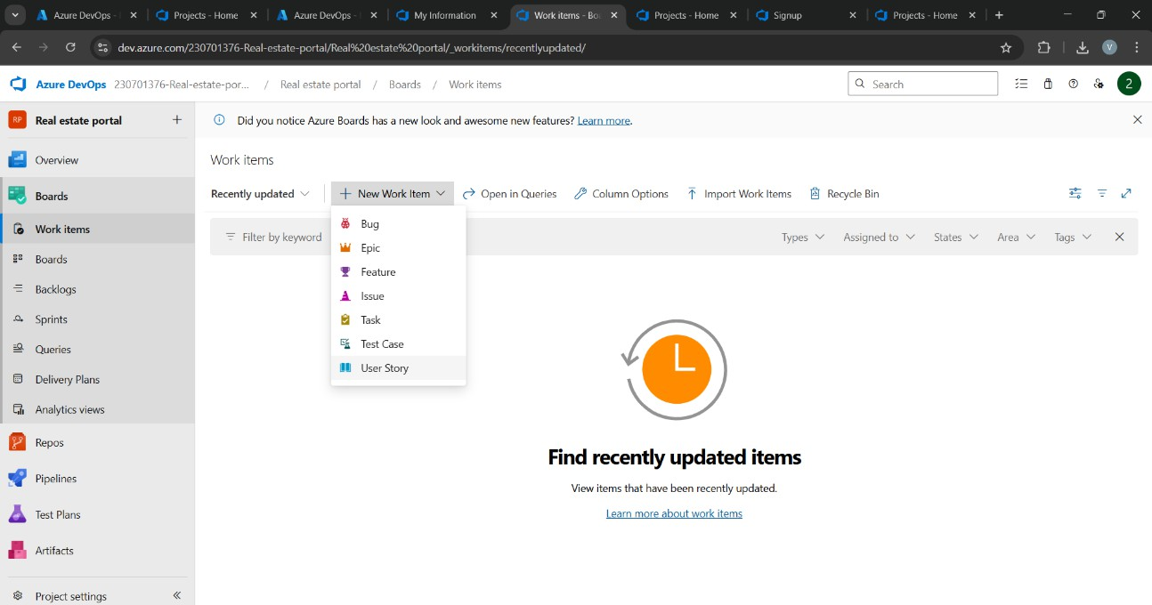

1. Fill in User Story Details

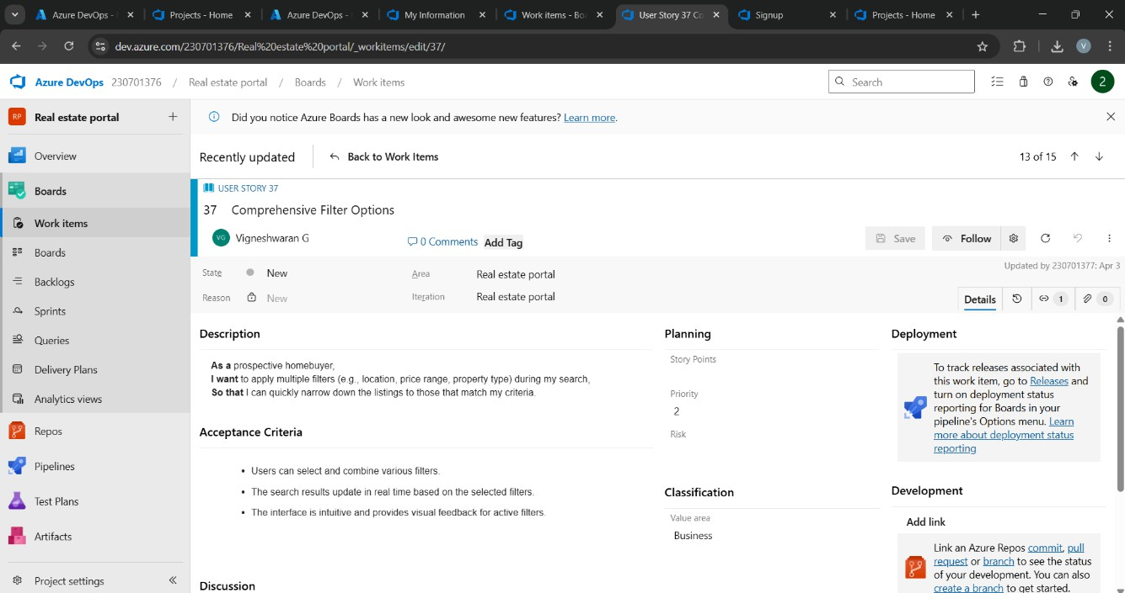

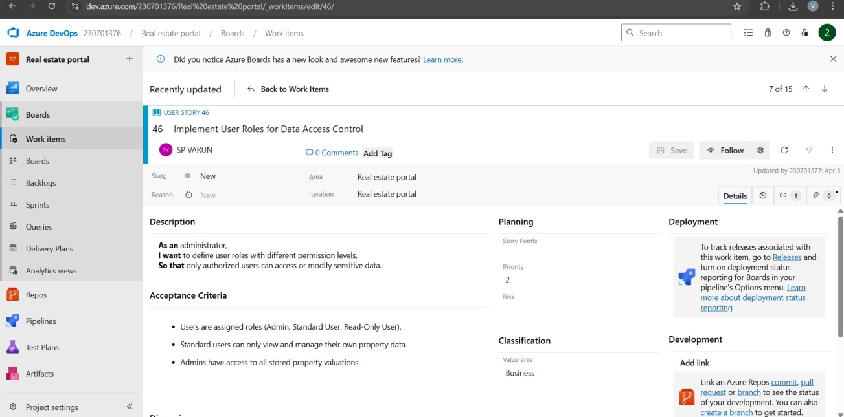

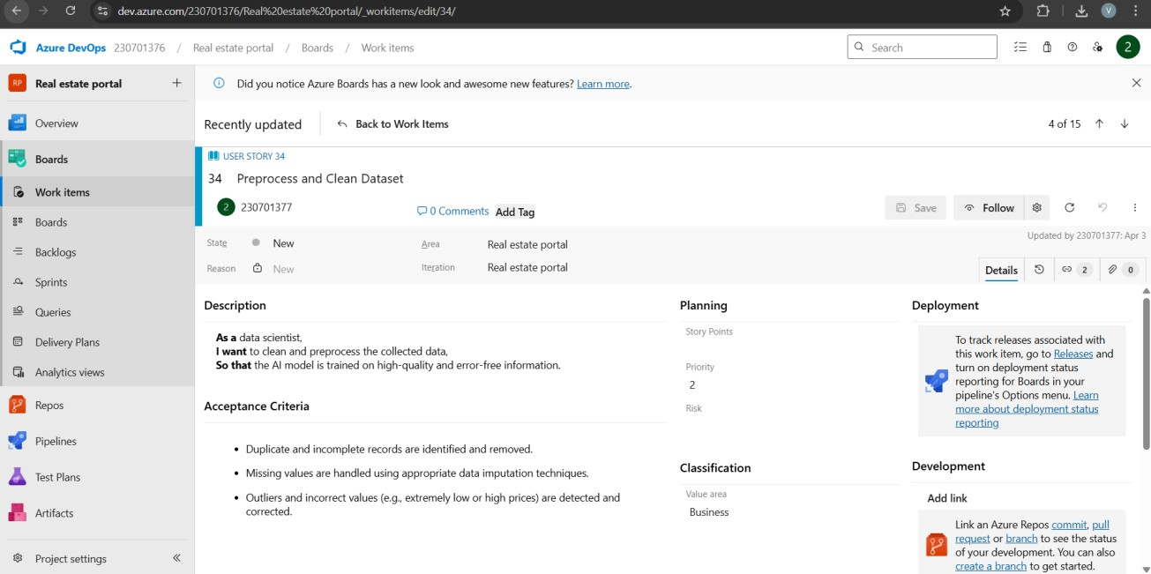

## Result:

The user story was written successfully.

# EX NO: 5

## Aim:

# SEQUENCE DIAGRAM

To design a Sequence Diagram by using Mermaid.js

# THEORY:

A Sequence Diagram is a key component of Unified Modelling Language(UML)used to visualize the interaction between objects in a sequential order. It focuses on how objects communicate with each other over time, making it an essential tool for modelling dynamic behaviour in a system.

## Procedure:

1. Open a project in Azure DevOps Organisations.
2. To design select wiki from menu

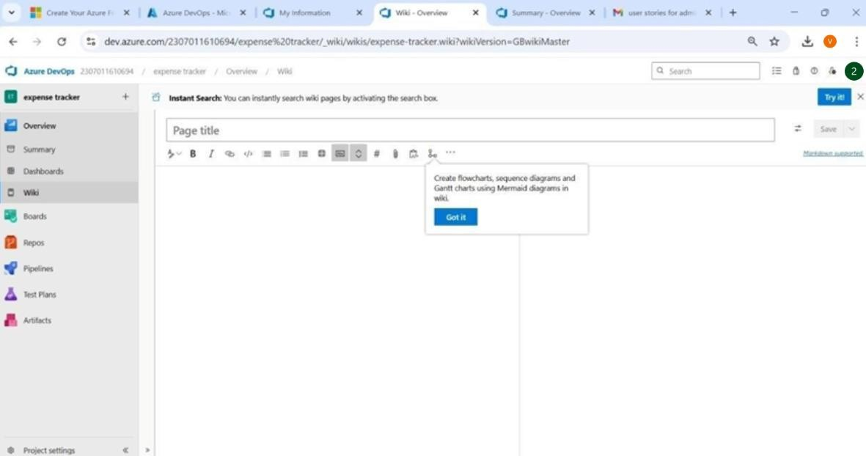

1. Write code for drawing sequence diagram and save the code:

::: mermaid sequenceDiagram

actor User participant Builder participant Portal participant Database

User->>Builder: post properties details Builder->>Portal: Store property details

Portal->>Database: Store property details Database-->>Portal: Confirmation

Portal-->>Builder: Confirmation Builder-->>User: Property listed

User->>Builder: Search properties Builder->>Portal: Query properties Portal->>Database: Query properties Database-->>Portal: Property list Portal-->>Builder: Property list Builder-->>User: Display properties

User->>Builder: Post review Builder->>Portal: Store review Portal->>Database: Store review Database-->>Portal: Confirmation Portal-->>Builder: Confirmation Builder-->>User: Review posted

User->>Portal: Login request alt Access granted

Portal-->>User: Login successful User->>Builder: post new project

Builder->>Portal: Store project details Portal->>Database: Store project details Database-->>Portal: Confirmation Portal-->>Builder: Confirmation

Builder-->>User: Project posted else Access denied

Portal-->>User: Login failed end

:::

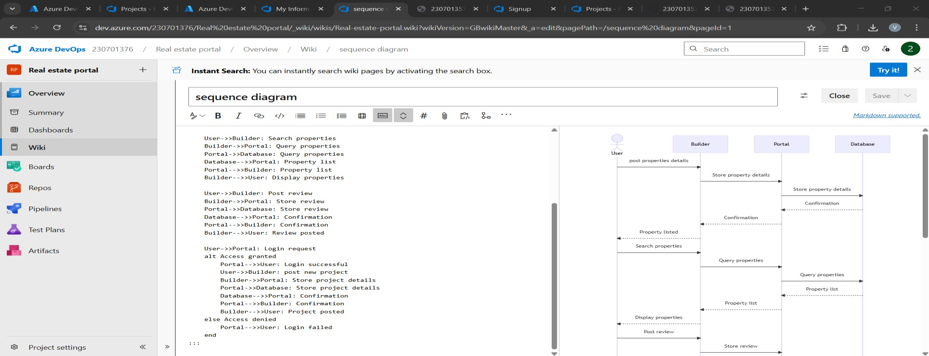

1. Click wiki menu and select the page

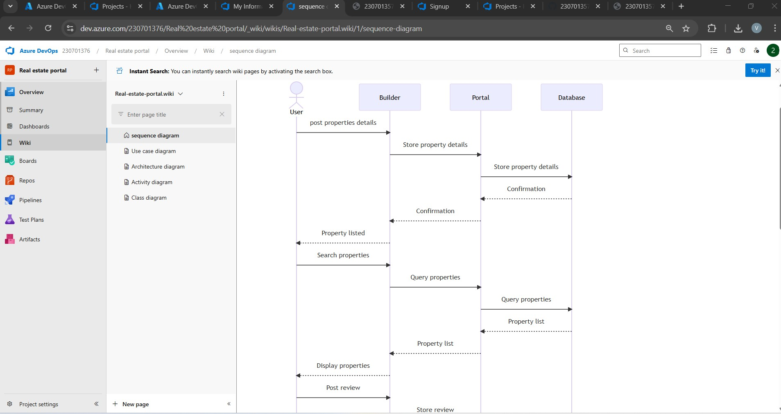

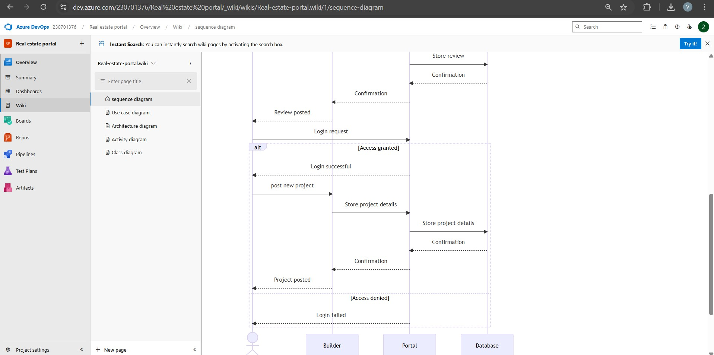

## Result:

The sequence diagram was drawn successfully.

**EX NO. 6**

**CLASS DIAGRAM**

**AIM :-**

To draw a sample class diagram for your project or system.

# THEORY

A UML class diagram is a visual tool that represents the structure of a system by showing its classes, attributes, methods, and the relationships between them.

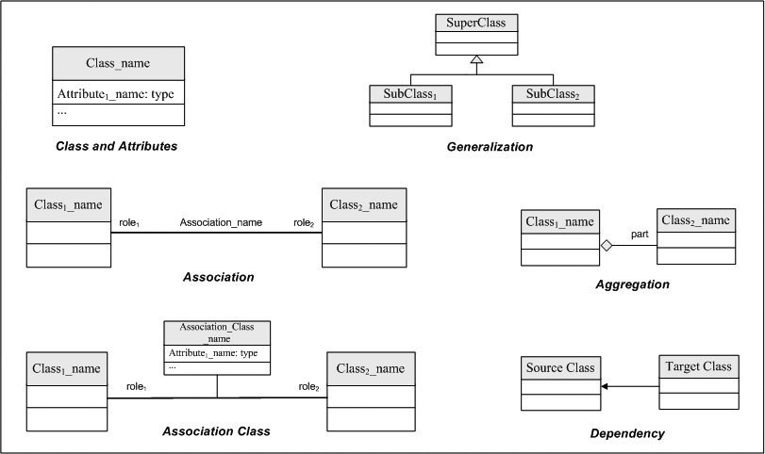

Notations in class diagram

Procedure:

1. Open a project in Azure DevOps Organisations.
2. To design select wiki from menu

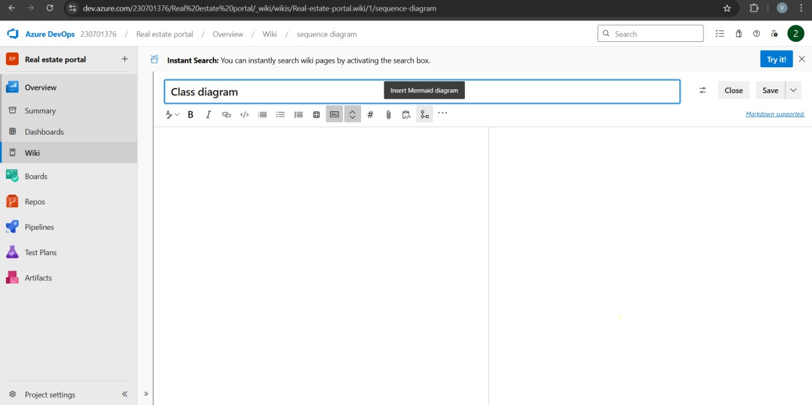

1. Write code for drawing class diagram and save the code

::: mermaid classDiagram direction LR

class User {

-userID: int

-name: string

-email: string

+register()

+login()

+postReview()

}

class Property {

-propertyID: int

-title: string

-price: float

-location: string

-BHK: int

+addProperty()

+updateDetails()

}

class Review {

-reviewID: int

-rating: int

-comment: string

+addReview()

}

class Project {

-projectID: int

-title: string

-location: string

+addProject()

}

class Builder {

-builderID: int

-companyName: string

+postProject()

}

User "1" --> "*" Property : owns Property "*" --> "1" User : listedBy

User "1" --> "*" Review : writes Review "*" --> "1" Project : about

Builder --|> User

Builder "1" --> "*" Project : creates Project "*" --> "1" Builder : belongsTo

:::

Type Description

<| Inheritance

\* Composition

o Aggregation

> Association

< Association

|> Realization

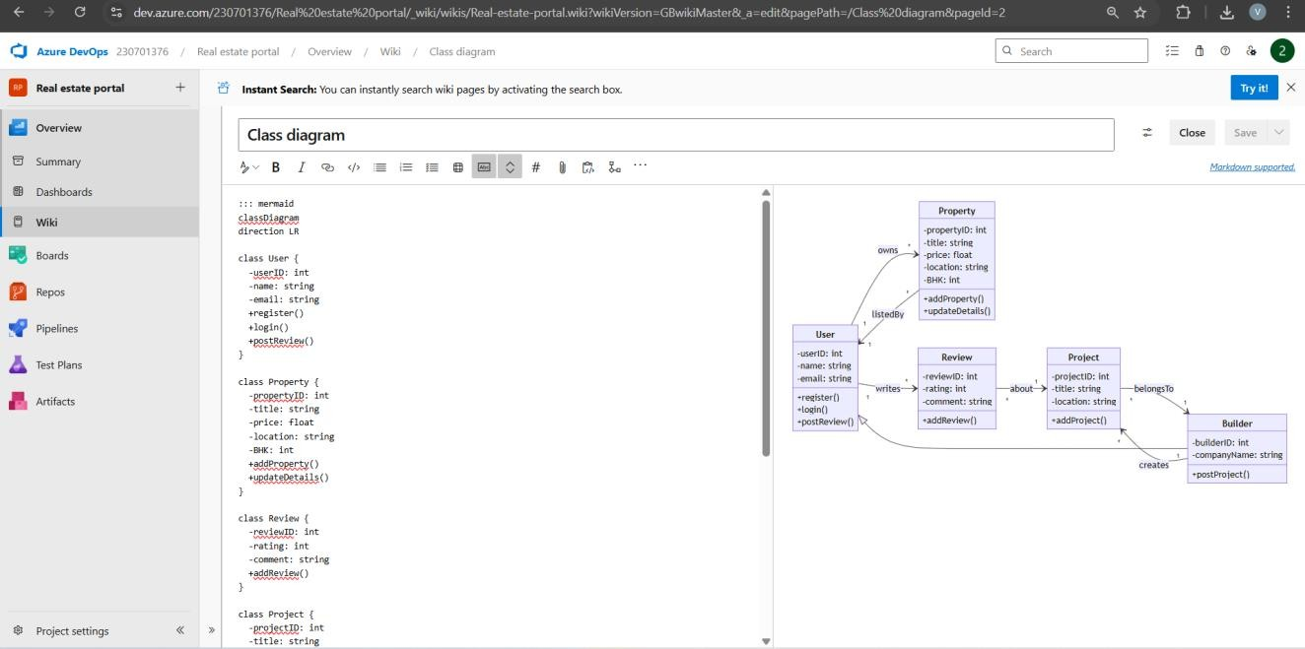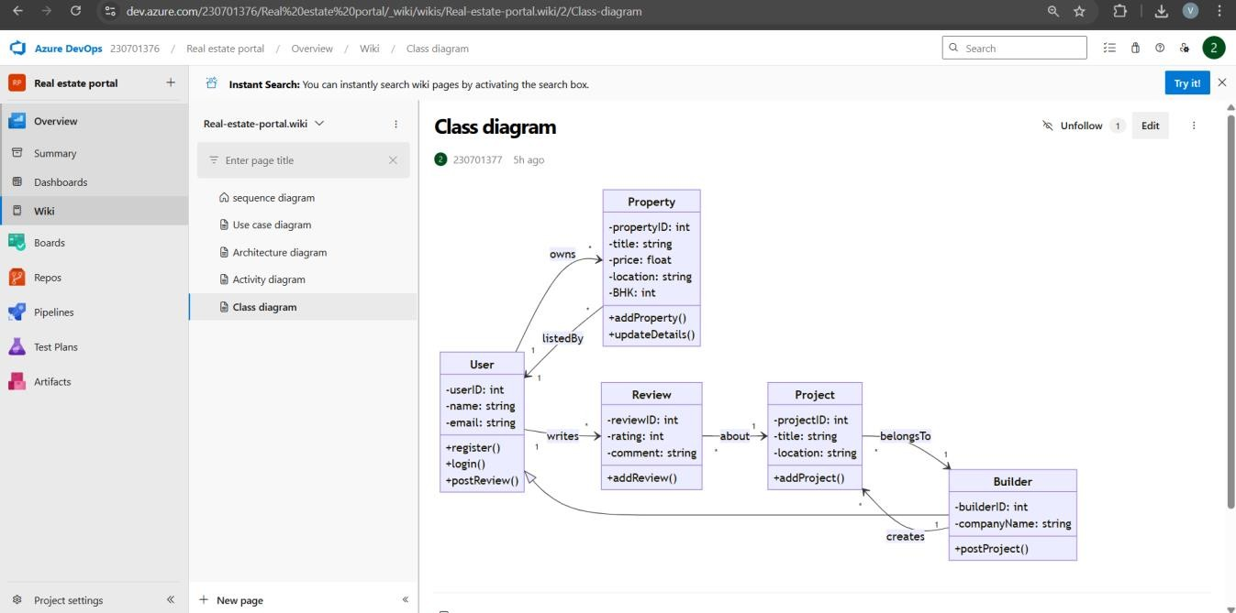

## Result:

The use case diagram was designed successfully.

# EX NO: 7

**Aim**:

# USECASE DIAGRAM

Stepsto draw the Use Case Diagram using draw.io

## Theory:

* UCD shows the relationships among actors and use cases within a system which Provide an overview ofallorpartoftheusagerequirementsforasystemororganization in the form of an essential model or a business model and communicate the scope of a development project
  + **Use Cases**
  + **Actors**
  + **Relationships**
  + **System Boundary Boxes**

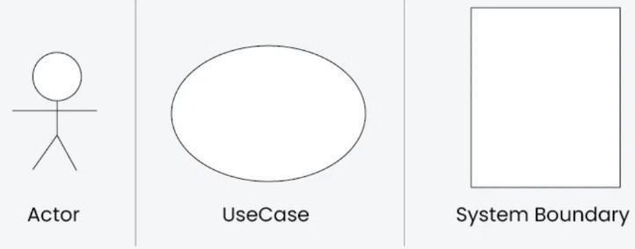

**Procedure**

Step1: Create the Use Case Diagram in Draw.io

* + - Open Draw.io(diagrams.net).
    - Click "Create New Diagram" and select "Blank" or "UML Use Case"template.
    - Add Actors (Users, Admins, External Systems) from the UML section.
    - Add Use Cases (Functionalities) using ellipses.
    - Connect Actors to Use Cases with lines (solid for direct interaction, dashed for

<<include>> and <<extend>>).

* + - Savethediagramas.drawioorexportasPNG/JPG/SVG. Step 2: Upload the Diagram to Azure DevOps

Option 1: Add to Azure DevOps Wiki

* + - * Open Azure DevOps and go to your project.
      * Navigate toWiki(Project> Wiki).
      * Click "Edit Page" or create a new page.
      * Drag & Drop the exported PNG/JPG image.
      * Use Markdown to embed the diagram:
      * ![Use Case Diagram](attachments/use_case_diagram.png)

Option 2 : Attach to Work Items in Azure Boards

* Open Azure DevOps → Navigate to Boards (Project >Boards).
* Select a User Story ,Task or Feature.
* Click "Attachments" → Upload your Use Case Diagram.
* Add comments or descriptions to explain the use case.

## Output:

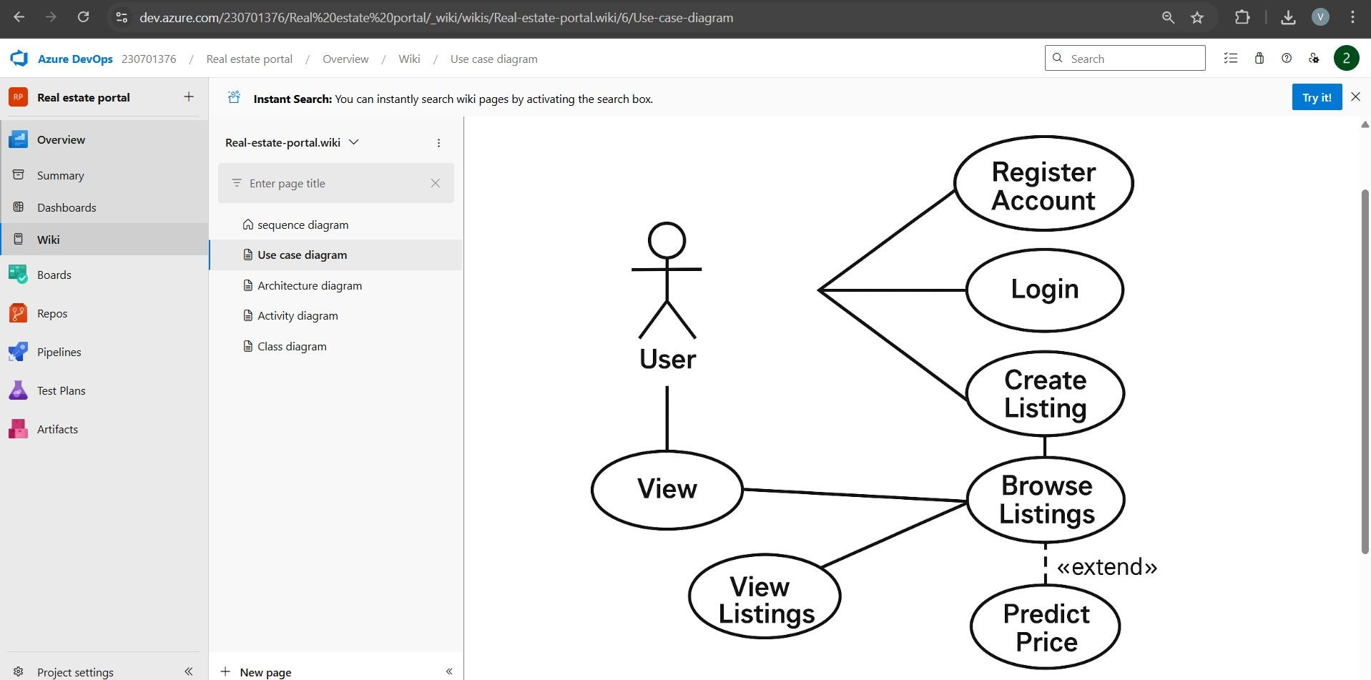

**Result:**

The use case diagram was designed successfully

**EX NO. 8**

**ACTIVITY DIAGRAM**

**AIM :-**

To draw a sample activity diagram for your project or system.

# THEORY

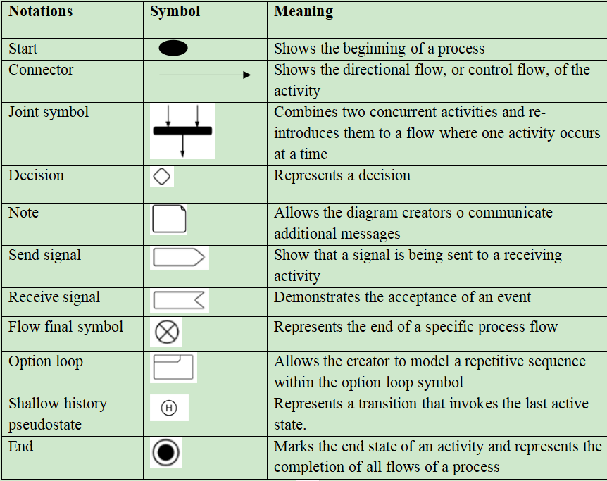Activity diagrams are an essential part of the Unified Modelling Language (UML)that help visualize workflows, processes, or activities within a system. They depict how different actions are connected and how a system moves from one state to another.

Procedure

1. Draw diagram in draw.io
2. Upload the diagram in Azure DevOps wiki

## Output

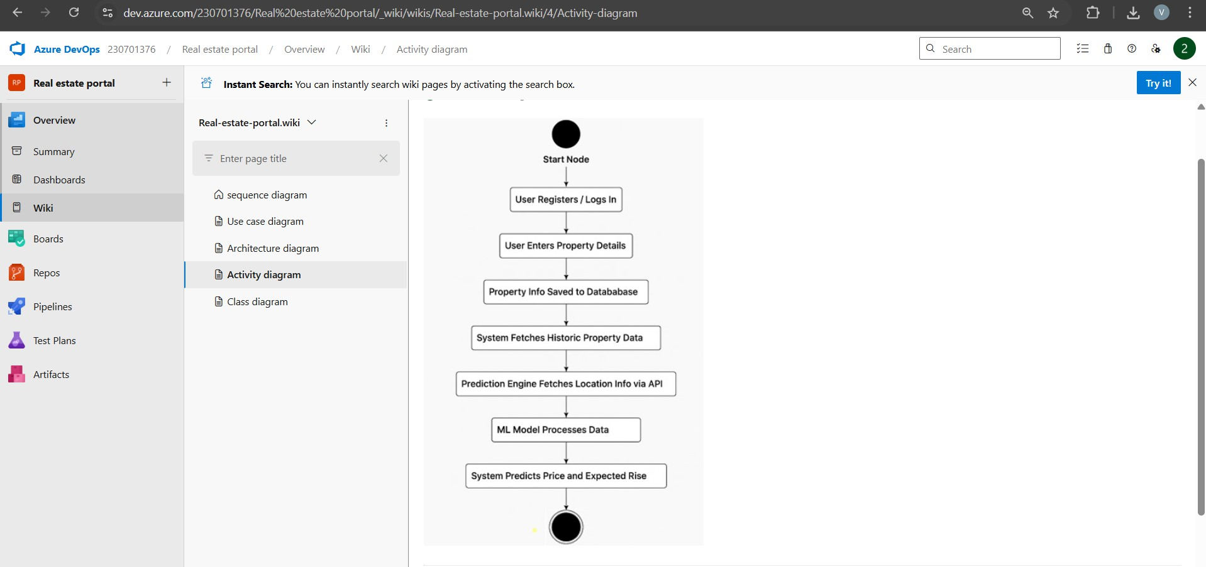:

## Result:

The activity diagram was designed successfully

# EX NO. 9

**ARCHITECTURE DIAGRAM**

## Aim:

Steps to draw the Architecture Diagram using draw.io.

## Theory:

An architectural diagram is a visual representation that maps out the physical implementation for components of a software system. It shows the general structure of the software system and the associations, limitations and boundaries between each element.

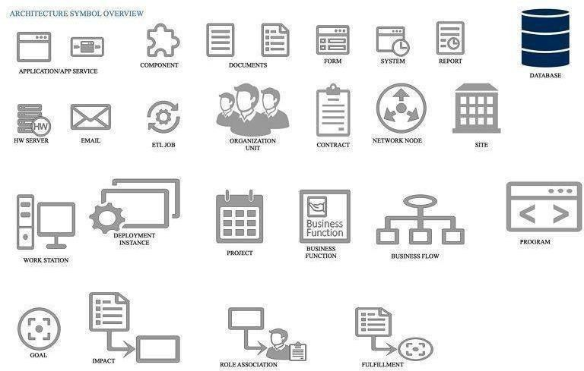

Procedure

1. Draw diagram in draw.io
2. Upload the diagram in Azure DevOps wiki

## Output

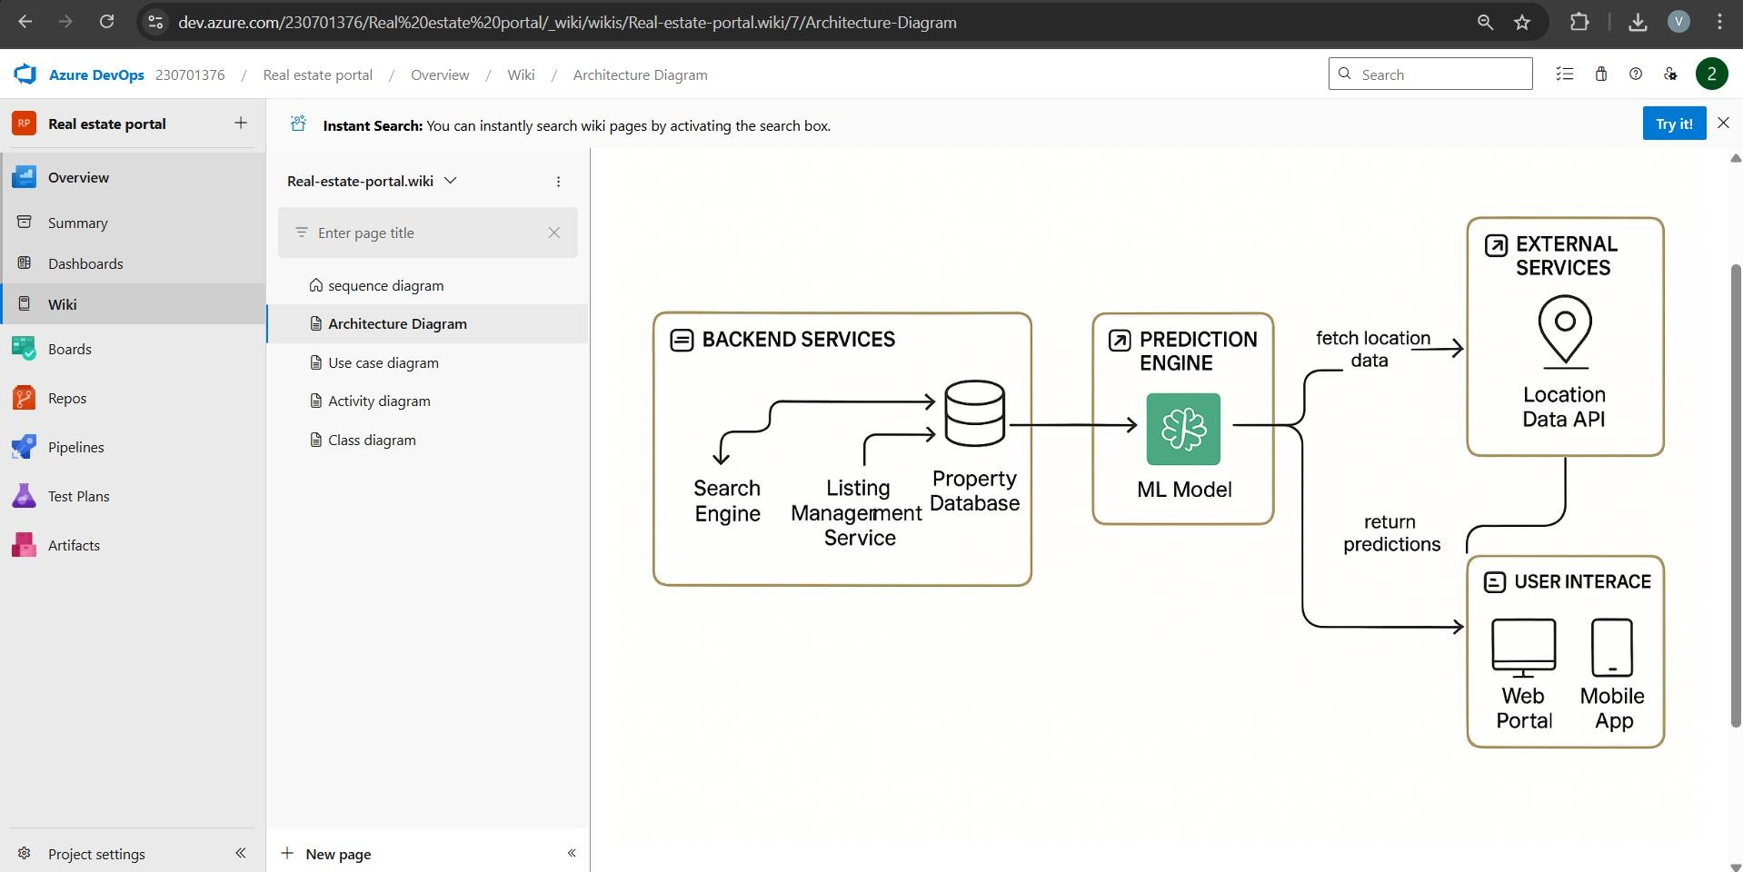

**Result:**

The architecture diagram was designed successfully

# EX NO. 10

**USER INTERFACE**

## Aim:

Design User Interface for the given project

## Output:

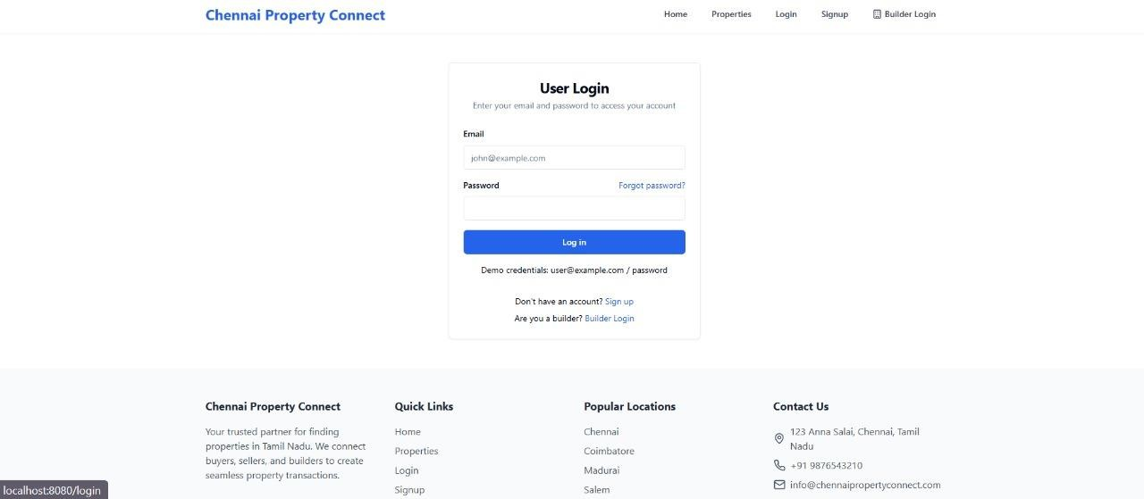

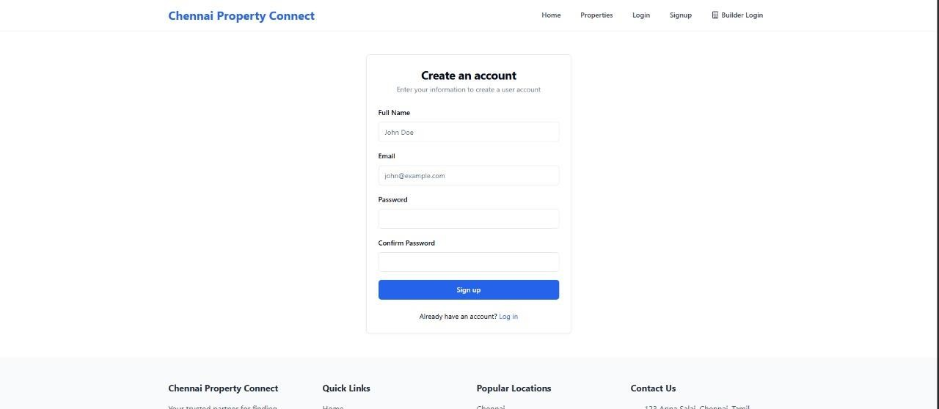

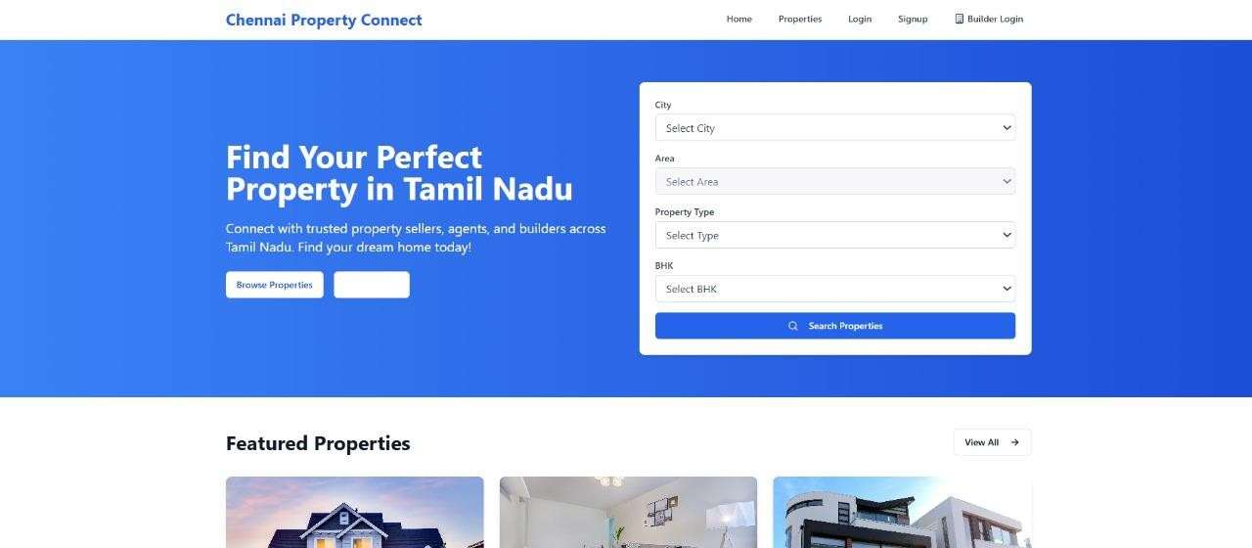

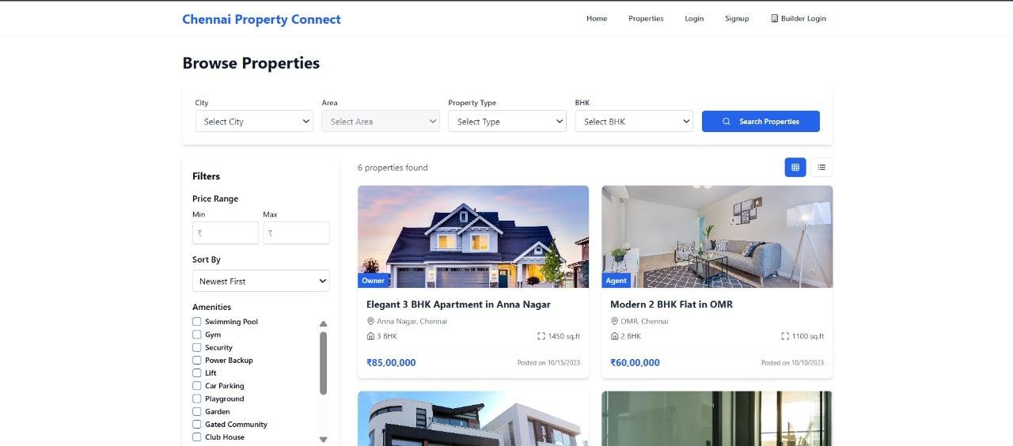

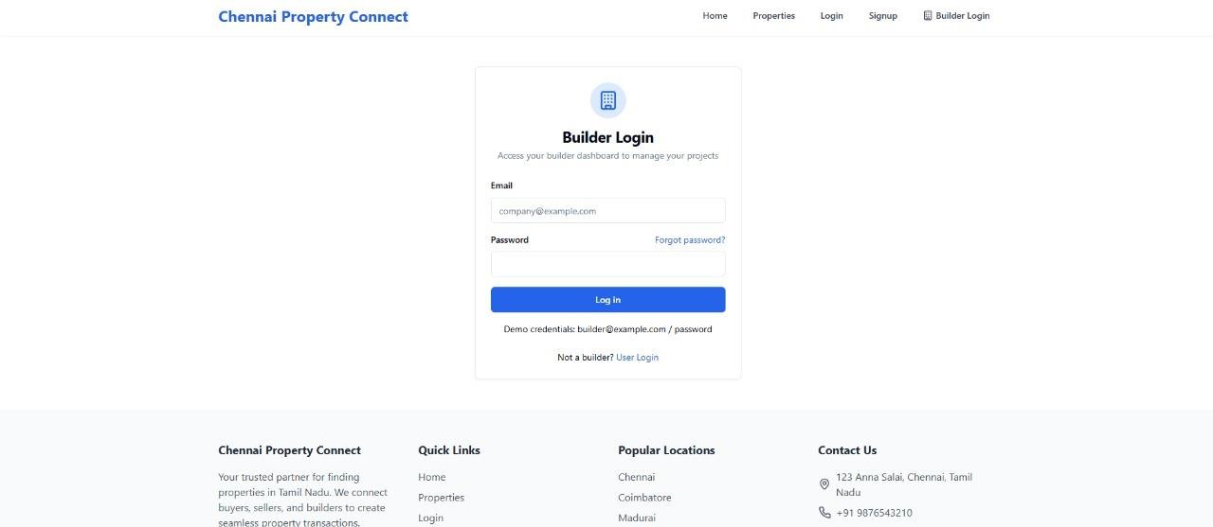

**Result:**

The UI was designed successfully.

# EX NO. 11

## Aim:

# IMPLEMENTATION

To implement the given project based on Agile Methodology.

Procedure:

Step 1: Set Up an Azure DevOps Project

* Log in to Azure DevOps.
* Click "New Project" → Enter project name → Click "Create".
* Inside the project, navigate to "Repos" to store the code.

Step2 : Add Your Web Application Code

* Navigate to Repos → Click "Clone" to get the Git URL.
* Open Visual Studio Code/Terminal and run: git clone <repo_url>

cd <repo_folder>

* Addwebapplicationcode(HTML,CSS,JavaScript,React,Angular,orbackendlike Node.js, .NET, Python, etc.).
* Commit &push:

git add .

git commit-m"Initial commit" git push origin main

Step 3: Set Up Build Pipeline (CI/CD - Continuous Integration)

* Navigate to Pipelines → Click "New Pipeline".
* Select Git Repository (Azure Repos, GitHub, or Bitbucket).
* Choose Starter Pipeline or a pre-configured template for your framework.
* Modify the azure-pipelines.yml file (Example for a Node.js app):

trigger:

- main

pool:

vmImage: 'ubuntu-latest'

steps:

* task:UseNode@1 inputs:

version: '16.x'

* script: npm install

displayName: 'Install dependencies'

* script: npm run build displayName:'Buildapplication'
* task:PublishBuildArtifacts@1 inputs: pathToPublish:'dist'artifactNa me: 'drop'

Click "Save and Run" → The pipeline will start building app.

Step 4: Set Up Release Pipeline (CD - Continuous Deployment)

* Go to Releases → Click "New Release Pipeline".
* Select Azure App Service or Virtual Machines (VMs) for deployment.
* Add an artifact (from the build pipeline).
* Configure deployment stages (Dev,QA,Production).
* Click "Deploy" to push your web app to Azure.

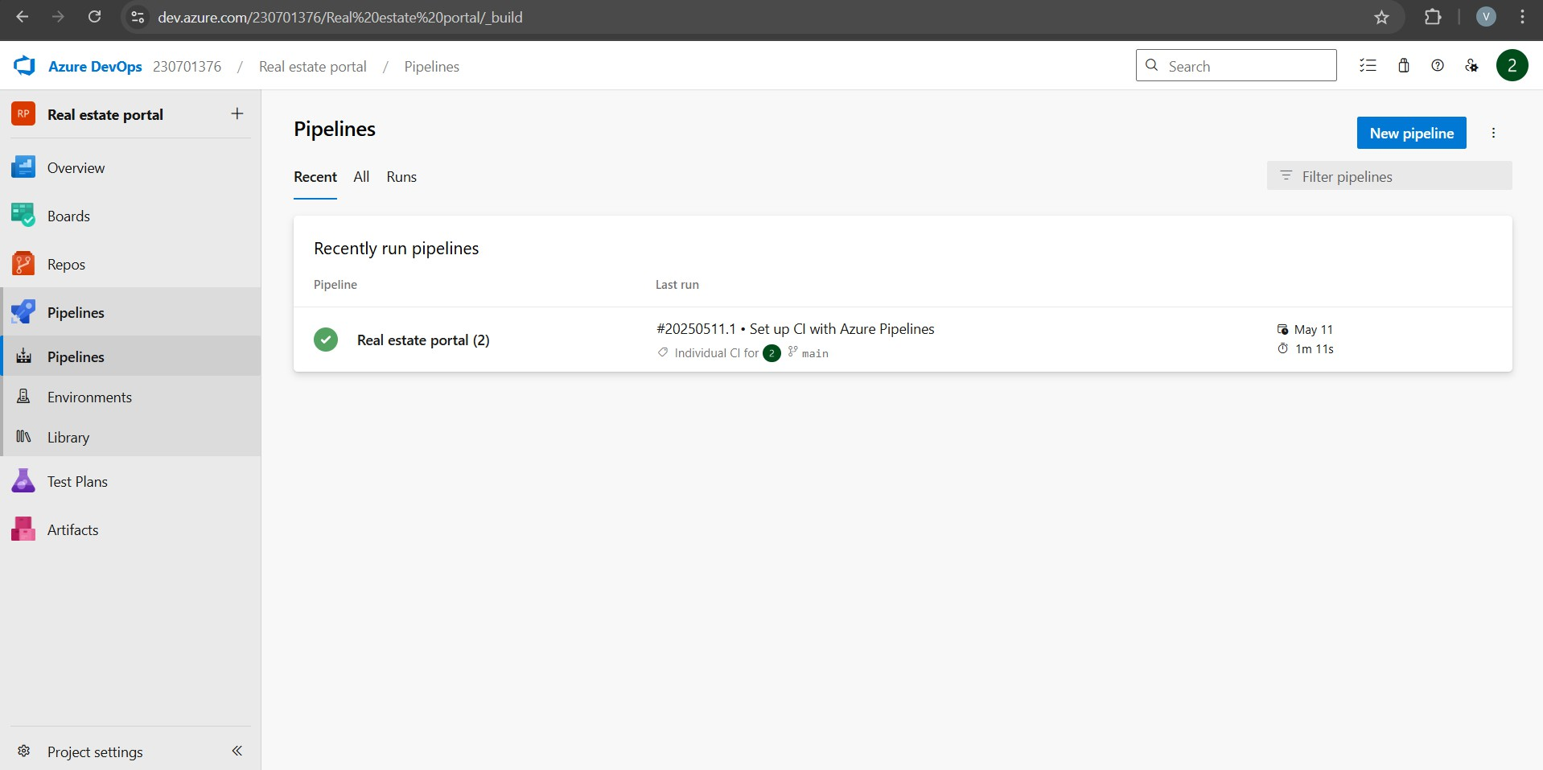

## Result

Thus the application was successfully implemented.